Pyber Analysis

According to the latest data available, the Urban and Suburban cities are providing the bulk of business with 93.2% of the customer base.

Driver availability might be leading this trend, with 80.9% of the drivers in the Urban cities alone.

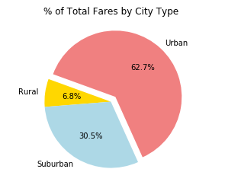 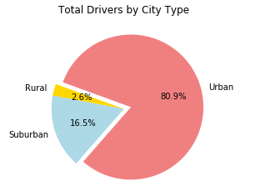

The rural communities provide a fraction of the total fares but on average they do pay more per ride. In fact, on average the Rural fares are 41% higher than the Urban.

An opportunity exists to recruit more drivers in the rural communities to allow for more customers to be able to use the service. In doing so we would not only be providing a service to those communities but we would be increasing total fares for the company.

